**Microprocessor Lab**

Laboratory Activity No. 1

**Familiarization with TinkerCAD**

|  |
| --- |
|  |

Score

*Submitted by:*

**Domingo, Angelo C.**

**<SAT 7am-1pm> / <Block 1>**

*Date Submitted*

**17-09-2023**

*Submitted to:*

**Engr. Maria Rizette H. Sayo**

1. Exercise

a. A process in Tinkercad where we can develop electronic circuits that can be quickly updated, modified and tested is called ________________. **Prototyping Process**

b. In Tinkercad, ________________________ tests the working of the circuits and the components. **Start/Stop Simulation**

c. The device used to assemble and connect the various components is known as __________ **Breadboard**

d. In an electronic circuit with LED, the positive end of the circuit should be connected to

___________ and negative end should be connected to _______________ of the LED. **Anode and Cathode**

e. A ________________ is used to restrict the flow of current to electrical components. **Resistor**

2. Label the following:



1. Anode and Cathode in a LED
2. Different parts of breadboard

Cathode Anode

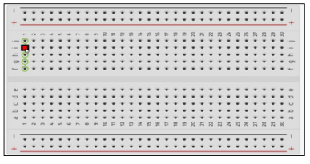

Edge =>

Main Area [

Edge =>

1. List the electronic components used in a circuit assembly

* Resistors
* Capacitors
* Inductors
* Diodes
* Transistors
* Integrated Circuits (ICs)
* Voltage Regulators
* Transformers
* Relays
* Switches
* Connectors
* LEDs (Light-Emitting Diodes)
* Potentiometers
* Crystal Oscillators
* Sensors
* Fuses and Circuit Breakers
* Printed Circuit Boards (PCBs)
* Photodetectors
* Resistor Networks
* Capacitive and Inductive Sensors